IW-08
YEAR 10 SCIENCE EXTENSION
ENERGY AND CHANGE
TEST - LIGHT

NAME: MARK: 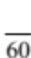
QUESTION | ANSWER
1
2
3
4
5
6
7
8
9
10
11
12
13
14
15
1. A person stands 2 metres in front of a plane mirror. The image of the person will
appear to be:

(a) 4 metres behind the mirror.
(b) 2 metres behind the mirror.
(c) on the mirror.
(d) 2 metres in front of the mirror.
(e) 4 metres in front of the mirror.

2. Which of the following statements is wrong?

(a) A concave mirror can be used as a headlight reflector in a car.
(b) A convex mirror can be used as a shop security mirror.
(c) A concave mirror can be used in telescopes.
(d) A convex mirror magnifies and can be used as a shaving or make-up
mirror.
(e) A convex mirror always produces a virtual mirror.

3. Refraction of light is:

(a) the wave motion of light as it passes through a substance.
(b) the bending of light as it passes from one substance into another.
(c) a reflection of light rays at the surface of a medium.
(d) the failure of light to pass through a very dense substance.
(e) none of the above.

4. Light entering glass from air:

(a) speeds up slightly and bends towards the normal.
(b) speeds up slightly and bends away from the normal.
(c) slows down slightly and bends away from the normal.
(d) slows down slightly and bends towards the normal.

5. Sometimes, when light travels from a substance into another which has a lower
refractive index (e.g. from glass into air), the light reflects from the boundary and
is unable to escape from the first substance. This total internal reflection happens
when the angle between the light ray and the normal is:

(a) 0°C.
(b) less than the critical angle.
(c) greater than the critical angle.
(d) 90°C.

6. Which of the following statements is not correct?

(a) Light only travels through a vacuum.
(b) Light is a form of energy.
(c) Light is a form of wave motion.
(d) Light is electromagnetic radiation.
7. The greater the curvature of a convex lens:

(a) the more it bends light and hence the shorter the focal length.
(b) the more it bends light and hence the longer the focal length.
(c) the less it bends light and hence the shorter the focal length.
(d) the less it bends light and hence the longer the focal length.

8. Light travels in _____ lines.

(a) diagonal
(b) curved
(c) horizontal
(d) straight

9. A person standing on a bank beside a river attempting to spear a fish under the water must aim:

(a) below the apparent position of the fish because light rays coming from the fish are refracted away from
the normal when passing into the air.
(b) below the apparent position of the fish because light rays coming from the fish are refracted towards the
normal when passing into the air.
(c) above the apparent position of the fish because light rays coming from the fish are refracted towards the
normal when passing into the air.
(d) above the apparent position of the fish because light rays coming from the fish are refracted away from
the normal when passing into the air.

10. Select the statement that is incorrect.

(a) People with "long sight" can see distant objects clearly.
(b) Long sightedness can be corrected with a concave lens.
(c) People with "short sight" can see near objects clearly.
(d) Objects at different distances are brought into focus by changing the curvature of the lens in the eye.
(e) Binocular vision enables humans to judge distances.

11. The sensitive part at the back of the eye where an image forms is called the:

(a) pupil.
(b) iris.
(c) optic nerve.
(d) ciliary muscle.
(e) retina.

12. Which of the following image/lens combinations is not possible?

(a) A diminished, upright, real image formed by a concave lens.
(b) A diminished, inverted, real image formed by a convex lens.
(c) An enlarged, inverted, real image formed by a convex lens.
(d) An enlarged, upright, virtual image formed by a convex lens.

13. When the nerves in the retina and the brain retain an impression of fan image for about 0.10 s after the object is
removed, the phenomenon is known as:

(a) the blind spot.
(b) long-sightedness.
(c) short-sightedness.
(d) persistence of vision.
(e) binocular vision.

14. _____ mirrors cause light to diverge.

(a) Plane
(b) Convex
(c) Concave
(d) Flat

15. A lens can be used to form images because:

(a) light passing through the lens changes direction.
(b) the lens, being transparent, attracts light.
(c) light is concentrated into a thin ray inside the lens.
(d) the lens reflects light.

Short Answer Write the answer to the questions in the spaces provided.

1. In the table below, choose the correct meaning for each word given. Write the letter of the correct meaning
next to the word.

WORD | CORRECT  LETTER | MEANINGS
concave lens |  | A - part of the electromagnetic spectrum used for cooking.
X-rays |  | B - causes skin cancer in humans.
convex mirror |  | C - always produces images that are the same size as the object.
real image |  | D - spreads out light rays when reflecting light.
microwaves |  | E - part of the electromagnetic spectrum used for medical purposes.
convex lens |  | F - corrects short sightedness in humans.
ultraviolet light |  | G - can be shown on a screen.
plane mirror |  | H - converges light rays.
(4)

2. (a) Complete the following diagram of the electromagnetic spectrum.

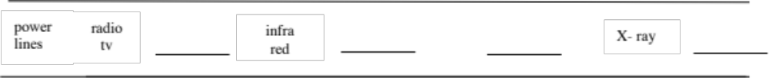
(2)

(b) Name one use for each of the forms of light mentioned below.

Radio/TV:

Infra-red:

X-ray:

(3)
3. Draw clear ray diagrams to show the following.

(a) A plane mirror forming a virtual image.

(2)

(b) A convex lens producing an image that is the same size as the object.

(2)

(c) A convex mirror forming an image.

(2)

4. Draw the path of the rays in the following diagrams.

g
l
a
s
s

g
l
a
s
s

(5)

5. An object 20.0 cm high is located 15.0 cm from a convex mirror of focal length 10.0 cm. Determine the size,
nature and position of the image formed. Set your working out clearly.

(6)
6. A lens produces a real image of an object 20.0 cm high. The image is 15.0 cm high when the object is 50.0 cm
from the lens.

(a) What type of lens is used?

(1)

(b) What is the magnification produced by the lens?

(2)

(c) Use your answer to part (b) to calculate where the image is formed.

(2)

(d) What is the focal length of the lens?

(2)

7. (a) Label the parts of the eye on the diagram below.

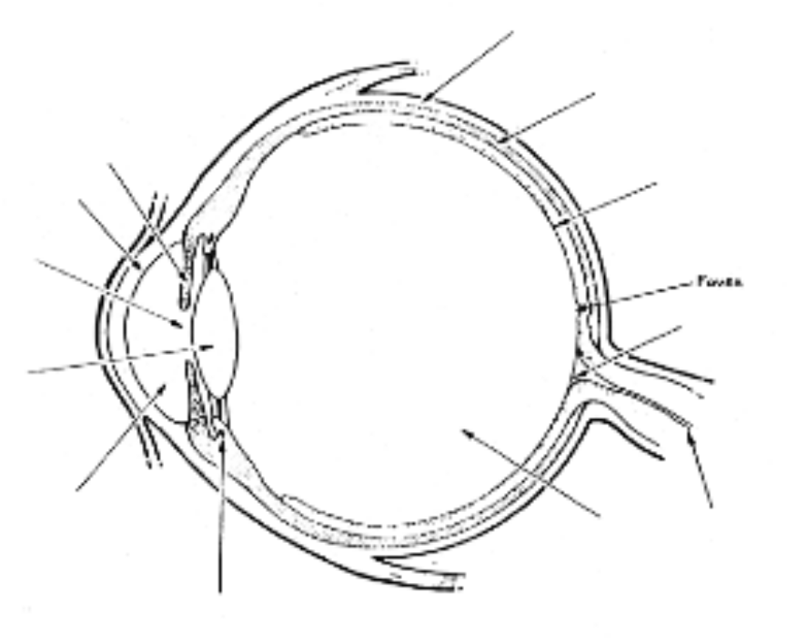
(5)

(b) Describe the role of the following parts of the eye.

pupil:

lens:

ciliary muscles:

iris:

(4)

7. (a) What does it mean when the eye is long-sighted?

(1)

(b) Give two reasons why this may occur in the eye.

(i)

(ii)

(b) How is this overcome?

(2)

